**CHECKS & BALANCES**

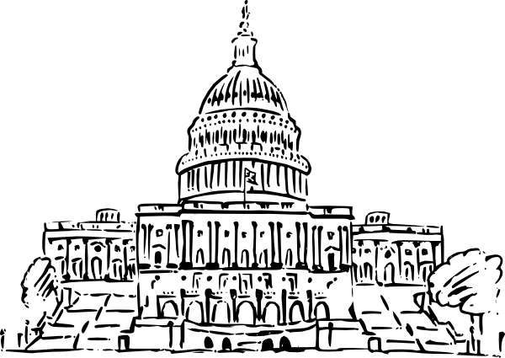

Directions: Use the 2 “Checks and Balances Examples” documents on my website to fill in the chart. Place the checks on the arrow pointing FROM the branch that has the check TO the branch that is limited by the check.

**Legislative**

 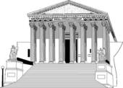

**Executive Judicial**